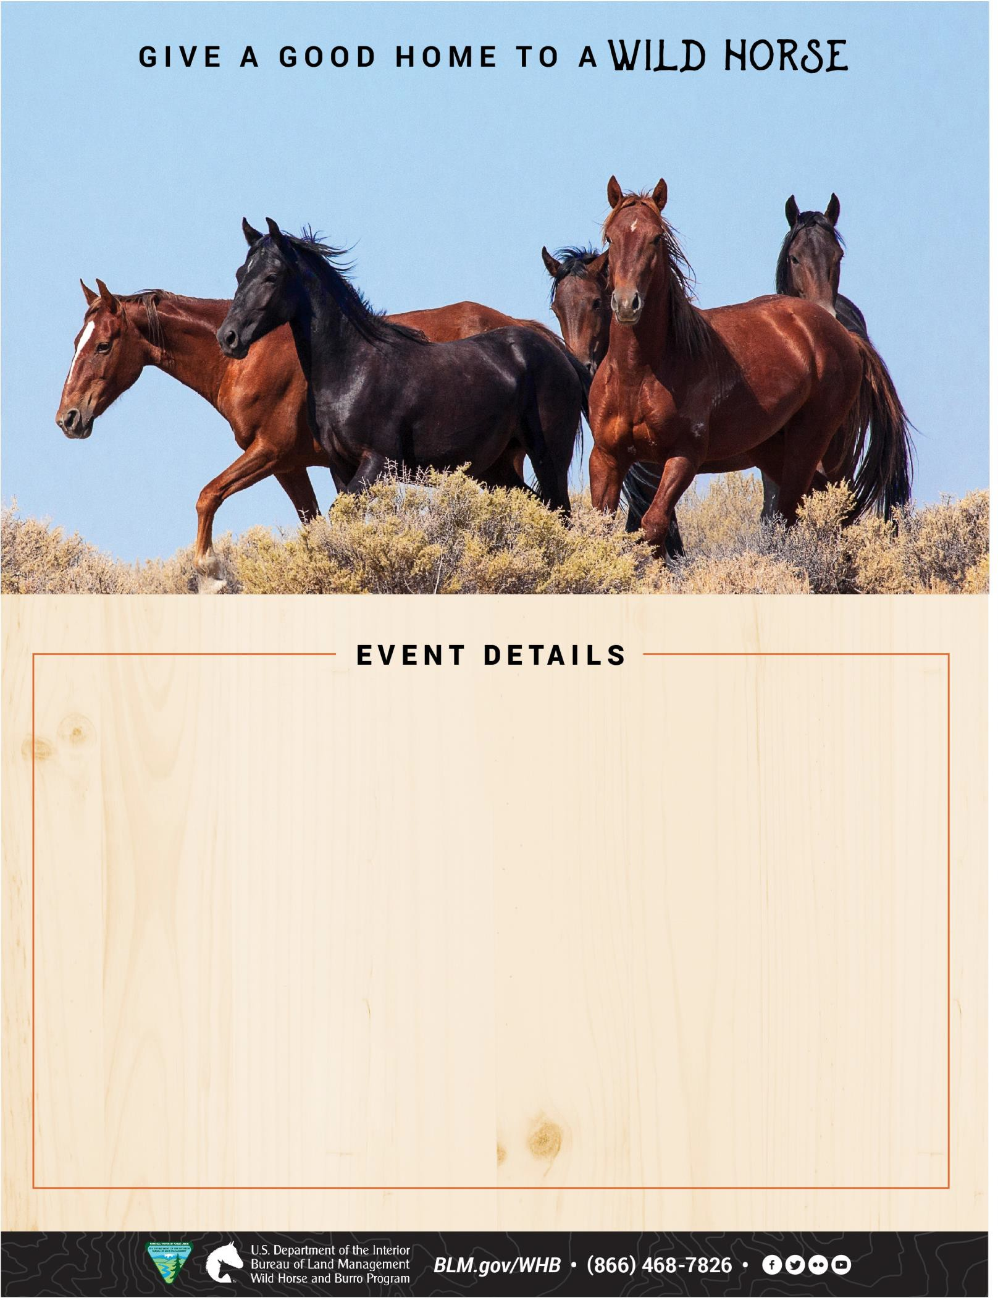

ELKHART, IA August 8 – 9, 2025

APPOINTMENT PREFERRED
Prairie Rose Arena
11045 NE 56th Street
Elkhart, IA 50073

$125 minimum fee for animals adopted
$25 minimum fee for animals purchased

Friday, August 8, 2025
Appointments from: 8 a.m. – 5 p.m. CDT

Saturday, August 9, 2025
Appointments from: 8 a.m. – 1 p.m. CDT

Email appointment request:
BLM_ES_NSDO_WHB@blm.gov
One-hour increments for both days (five appointments per hour)
Please indicate your TOP 3 preferred time slots prior to event.
Come and adopt a horse or learn more about the program.

